Admin/CMS Access is your domain/URL with the addition to /admin
Example: www.yourwesite.com/admin
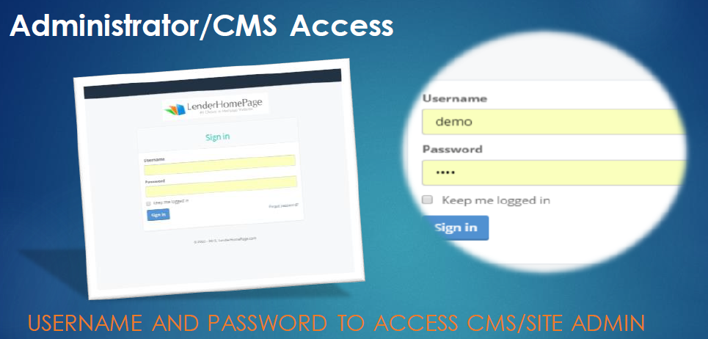

Choose the Leads Tab in the Left Blue Column
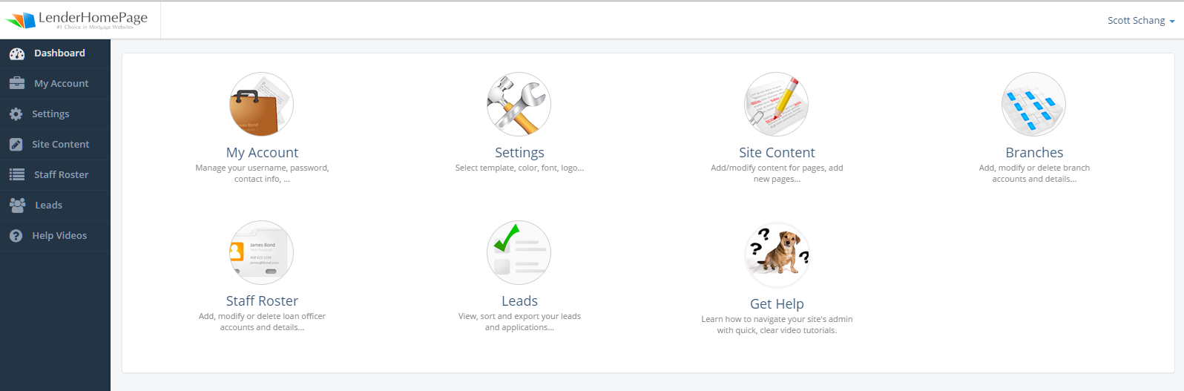

The SmartApp is the 2nd option in drop down menu.
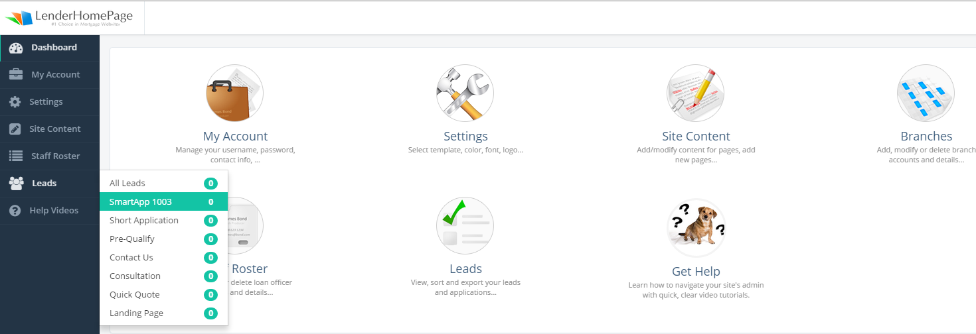

A new tab will open with the list of SmartApps. To download or Import the SmartApp please choose one or both of the following options
- FNM is the Fannie Mae file. You will click and save to desktop for import to LOS
- PDF- Upload the legal pdf to modify, add, and remove information.

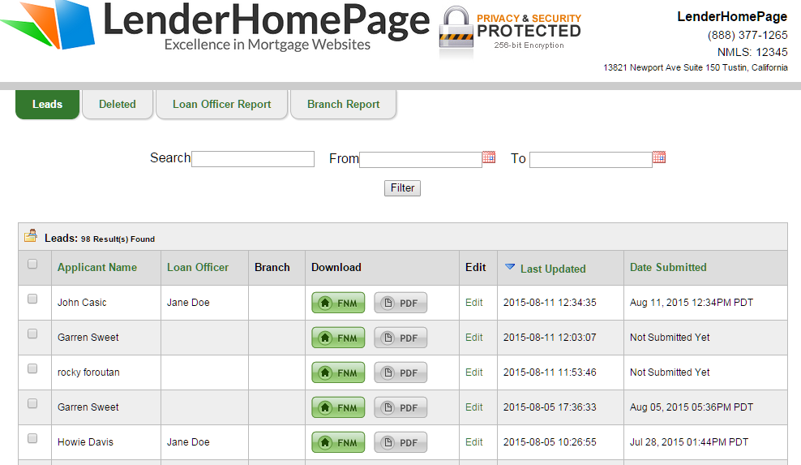

Smart Application
- FNM Legal Fannie Mae 3.2
- Save to desktop or folder location on desktop
- Access LOS to Import FNM
Or
Open the pdf.

